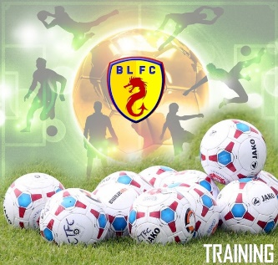
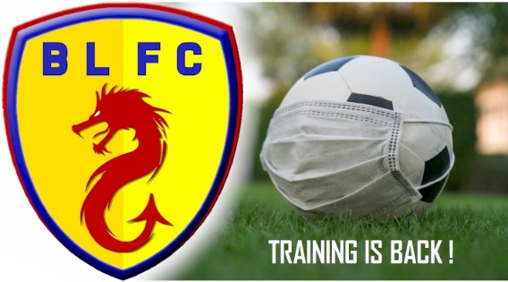

Boxted 2020/21 Season Training Starts
The club is happy to announce the first official Boxted Adult Training Session for the 2020/21 season will be held on Saturday 27th June 2020. Start time is 3pm, at Cage Lane, Boxted.
The plan is to hold twice weekly sessions dependant on attendance (Wednesday 7pm and Saturday 3pm). With the current COVID-19 situation the club has designed/planned the sessions to adhere to the latest FA Guidelines and follow all social distancing protocols.
The FA players guidelines can be found on the following link : CLICK HERE
As part of the process the coaches have to carry out a detailed risk assessment which includes maintaining a register of players. To allow us to comply all players and coaches who attend training must complete our COVID-19 training form before each individual session.
Please complete on the day of training and preferably as close to the training session as possible (but before you get to Cage Lane as you know how poor the signal is there !!!).
If you haven’t completed the online form you won’t be able to take part but it only takes 2 seconds to complete.
CLICK HERE For the form, or it can be found on our website www.boxtedlodgers.co.uk towards the bottom of the home page.

Key points to ensure you minimise the risk to everyone and allow us all to enjoy our football safely:
- Be aware of your club’ s training protocols which should be in line with Government guidance for COVID-19. As a player it is your responsibly to comply !
- If you are showing or have shown any COVID-19 symptoms in the last 14 Days – STAY AWAY !
- No first aid for injuries will be administrated by the club.
- Bring, use and be responsible for your own equipment. (inc Water Bottles etc - Ensure they are named so don’t get mixed up).
- Turn up for the session as close to the start time as possible. Avoids any unnecessary gatherings for long period of times.
- When the session is finished, you should leave the venue quickly rather than congregate.
- The Club House will NOT be open for use.
- If in doubt, or you’re not comfortable returning to football, DON'T.
See you all on Saturday. Football is back !!!!

